**AI-BASED TRAFFIC MANAGEMENT SYSTEM AND EDGE COMPUTING IN TRANSPORTATION SYSTEM**

**BY**

**AJOBIEWE WISDOM UKAMUMI**

**MATRIC NUMBER: CSC/18/927**

**A PROJECT SUBMITED TO**

**DEPARTMENT OF COMPUTER SCIENCE, SCHOOL OF SCIENCE,**

**OLUSEGUN AGAGU UNIVERSITY OF SCIENCE AND TECHNOLOGY, OKITIPUPA, ONDO STATE.**

**IN PARTIAL FULFILMENT OF THE REQUIREMENTS FOR THE AWARD OF BACHELOR OF TECHNOLOGY DEGREE (B. TECH) IN COMPUTER SCIENCE.**

**AUGUST, 2024**

DECLARATION

I, **Ajobiewe Wisdom Ukamumi,** Computer Science Department, hereby declared that all information and activities reported in this project report was written and carried out by me during the period of research. All sources of information are clearly acknowledged by means of references.

Signature……………………………... Date………………………………

CERTIFICATION

This is to certify that this project work was carried out by **Ajobiewe Wisdom Ukamumi** with Matriculation Number **CSC/18/927** and submitted to the Department of Computer Science, School of Science, Olusegun Agagu University of Science and Technology having met the standards as required by the institution and approved as to contents and styled by:

**Eger M. Agagu ……………………………**

**Project Supervisor Signature/Date**

**Professor Adebayo O. Adetunmbi ……………………………**

**HoD, Computer Science Signature/Date**

**PROF. A.S SODIYA ……………………………**

**External Examiner Signature/Date**

DEDICATION

This project is dedicated to God almighty and my mum.

ACKNOWLEDGEMENT

I wish to register my profound gratitude to Almighty God for His guidance, grace, and protection throughout my life and this academic journey. His presence has been a constant source of strength and inspiration.

I would like to extend my deepest appreciation to my beloved mother, Aiyedun Elizabeth, whose unwavering love and support have been the cornerstone of my achievements. My heartfelt thanks go to my grandma, Aiyedun Margret, for her wisdom and prayers, and to my uncles, Aiyedun Victor and Aiyedun Emmanuel, and my aunties, Aiyedun Antonia and Aiyedun Joy Naomi, for their invaluable advice, encouragement, and support throughout this journey.

To my siblings and friends, Nosakhare Treasure, Lawalson Heritage, Oluwasesan Peace, Ablite, and Adepoju Peter, who have been my pillars of support, I say thank you. May Almighty God continue to shower you all with abundant blessings, Ameen.

To my esteemed supervisor, Engr. M. Agagu, I deeply appreciate your tireless efforts, guidance, and dedication towards the success of this seminar. Your insights and constructive feedback have been instrumental in shaping this work.

In addition, I extend my special gratitude to the Head of Department for his immense contribution and support. I also wish to acknowledge all my amazing lecturers in the department for their seasoned lectures and invaluable guidance. Your commitment to education and mentorship has left an indelible mark on my academic path. May Almighty God bless you all abundantly.

TABLE OF CONTENTS

TITLE PAGE i

DECLARATION ii

CERTIFICATION iii

DEDICATION iv

ACKNOWLEDGEMENT v

TABLE OF CONTENTS vi

LIST OF FIGURES x

LIST OF TABLES xi

ABSTRACT xii

CHAPTER ONE 1

INTRODUCTION 1

1.1 Background Information 1

1.2 Research Justification/Motivation 3

1.3 Statement of the Problem 5

1.4 Aim and Objectives 6

1.5 Scope of the Study 6

1.6 Significance of the Study 8

1.7 Organization of study 9

CHAPTER TWO 11

LITERATURE REVIEW 11

2.1 Overview of Traffic Management Systems 11

2.2 Edge Computing in Transportation 12

2.3 Vehicle Tracking Systems 13

2.4 Traffic Light Control Systems 14

2.5 Congestion Detection Techniques 15

2.6 Role of Machine Learning in Traffic Management 16

2.7 Application of Deep Learning in Traffic Flow Optimization 17

2.8 Related works 18

CHAPTER THREE 21

METHODOLOGY 21

3.1 Designing the Traffic Management System 21

3.1.1 System Architecture 22

3.1.2 Data Flow and Processing 22

3.2 Materials 24

3.2.1 Data Sources 25

3.2.2 Tools and Equipment 26

3.2.3 Software and Libraries 27

3.3. Data Preprocessing Steps 28

3.4 Methodology 29

3.4.1 Overview of Modelling Techniques 30

3.4.2 Convolutional Neural Network (CNN) Methodology 31

3.4.3 Long Short-Term Memory (LSTM) Methodology 32

3.4.4 Hybrid CNN-LSTM Approach 33

3.5 Model Training and Evaluation 34

3.5.1 Training Process 34

3.5.2 Evaluation Metrics 35

3.5.3 Model Validation 36

CHAPTER FOUR 38

IMPLEMENTATION AND RESULTS 38

4.1Implementation Details 38

4.1.1 Data Preparation 38

4.1.2 Model Architecture 39

4.1.3 Training Process 39

4.1.4 Evaluation Methodology 39

4.2 Model Performance Metrics 40

4.3 Detailed Analysis of Results 43

4.3.1 CNN Model Performance 43

4.3.2 LSTM Model Performance 43

4.3.3 Hybrid CNN-LSTM Model Performance 44

4.4 Visualization and Interpretation 44

4.5 Streamlit Application for Traffic Flow Optimization 46

4.6 Visual Analysis of Model Performance 46

CHAPTER FIVE 51

SUMMARY AND CONCLUSION 51

5.1 Summary 51

5.2 Conclusion 53

5.3 Future Work 55

5.4 Limitations 57

5.5 Contribution to Knowledge 58

REFERENCES 61

APPENDIX 64

# LIST OF FIGURES

**Figure 1.** An illustration of an intersection road. (*Jabakumar, A.K. 2023*) 2

**Figure 2.** The structure of cloud computing and edge computing. (Jabakumar*, A.K. 2023*) 12

**Figure 3**: Proposed system architecture for Smart Traffic management. 22

**Figure 4:** Proposed model flowchart for Traffic Management 24

Figure 5: model performance on different tasks 41

Figure 6: comparison of model performance metrics 42

Figure 7: Traffic Prediction using CNN. 45

Figure 8: Traffic Prediction using CNN. 45

Figure 9: Traffic Prediction using the Hybrid Model 46

Figure 10: Streamlit environment testing the trained models 48

Figure 11: Loss and MAE over Epochs (Training and Validation) 49

Figure12: Actual vs. Predicted Values Scatter Plot 49

Figure 13: Residuals Histogram 50

Figure 14: Model Prediction Distribution 50

Figure 15: Confusion Matrix 51

Figure16: Precision-Recall Curve 51

Figure 17: ROC Curve 52

Figure18: Feature Importance 52

LIST OF TABLES

Table 1: Model Performance Comparison 40

Table 2: Evaluation Parameters for Traffic Management Models 42

ABSTRACT

Effective traffic management has become a critical concern in today’s rapidly urbanizing areas, driven by the increasing number of vehicles on the road. This study investigates the application of advanced machine learning techniques to optimize traffic light control, vehicle tracking, and congestion detection. The research focuses on developing and implementing algorithms such as Convolutional Neural Networks (CNN), Long Short-Term Memory (LSTM) networks, and a Hybrid CNN-LSTM model to predict traffic patterns and dynamically allocate resources in real time. Utilizing a dataset composed of traffic metrics, time intervals, and vehicle counts, the models were trained and evaluated to improve urban traffic efficiency.

The CNN model achieved an accuracy of 0.8848, precision of 0.8843, recall of 0.8848, and F1 score of 0.8842. The LSTM model demonstrated an accuracy of 0.8546, precision of 0.8752, recall of 0.8746, and F1 score of 0.8746, while the Hybrid CNN-LSTM model recorded an accuracy of 0.8871, precision of 0.8689, recall of 0.8671, and F1 score of 0.8679. These models effectively enhanced traffic flow prediction, vehicle tracking accuracy, and congestion detection. However, the findings indicate that further refinements could lead to even more efficient traffic management. This research provides valuable insights into the deployment of machine learning models for real-time traffic optimization in complex urban environments.

Keywords: Traffic Flow Optimization, Traffic Management, Machine Learning, CNN, LSTM, Hybrid CNN-LSTM, Traffic Control, Model Evaluation Metrics.

CHAPTER ONE

INTRODUCTION

1.1 Background Information

Urbanization is on the rise globally, resulting in a significant increase in the number of vehicles on the roads. This growth has led to severe traffic congestion, particularly in metropolitan areas, causing delays, increasing fuel consumption, and contributing to environmental pollution through the release of greenhouse gases. The challenges of traffic congestion are not limited to delays but also extend to increased accident rates and reduced quality of life for urban residents.

To address these issues, cities worldwide have been seeking effective traffic management systems that can optimize vehicle flow, reduce congestion, and improve road safety. Traditional traffic management systems, which are often rule-based and reliant on fixed algorithms, have proven insufficient in dealing with the complexities of modern traffic conditions. These systems lack the flexibility to adapt to real-time fluctuations in traffic patterns, such as those caused by accidents, road closures, or sudden increases in vehicle volume.

In response to these limitations, researchers and urban planners have turned to intelligent traffic management systems that leverage advanced technologies such as machine learning (ML) and deep learning (DL). These systems can analyze vast amounts of traffic data, learn from patterns, and make informed decisions to optimize traffic flow. They also offer the potential for real-time adjustments to traffic control mechanisms, such as traffic lights, to reduce congestion and enhance the overall efficiency of road networks. (Kanagamalliga et al 2024; Madhuri et al 2023; Mchergui et al 2021).



**Intersection State**

**Intelligent Agent**

**N**

**Road-4**

**S**

**L2 L1**

**L1 L2**

**L1**

**L2**

**L2**

**L1**

**Figure 1.** An illustration of an intersection road. (*Jabakumar, A.K. 2023*)

Machine learning techniques, including supervised and unsupervised learning algorithms, have been increasingly applied to traffic management problems. These techniques can process and interpret data from a wide range of sources, including cameras, sensors, and GPS systems, to predict traffic conditions and provide actionable insights. For instance, ML models can be used to forecast traffic volume, detect congestion, and optimize traffic signal timings. (Mchergui et al 2021)

Deep learning models, particularly convolutional neural networks (CNNs) and recurrent neural networks (RNNs), have further advanced the field by enabling more sophisticated analysis of traffic data. These models can recognize complex patterns in traffic flow and make predictions that improve the responsiveness of traffic management systems(Mukto et al 2024). Deep learning techniques have been particularly effective in applications such as vehicle tracking, where high levels of accuracy are required to ensure effective traffic control.

The integration of machine learning and deep learning into traffic management systems represents a significant step forward in addressing the challenges posed by urbanization and increasing vehicle populations. By harnessing the power of these technologies, cities can move towards smarter and more efficient traffic management solutions that improve the quality of life for their residents. (Madhuri et al 2023)

1.2 Research Justification/Motivation

The rapid growth of urban populations and the subsequent rise in vehicle numbers have exacerbated traffic congestion issues, posing significant challenges to urban mobility, public health, and environmental sustainability. Traditional traffic management systems, which rely on pre-set rules and manual interventions, are no longer sufficient to address the dynamic and complex nature of modern traffic. These conventional systems often fail to adapt to sudden changes in traffic conditions, leading to inefficiencies, prolonged traffic jams, increased accident rates, and environmental degradation. (Khamari et al 2024)

The motivation behind this research stems from the urgent need to develop intelligent and adaptive traffic management systems that can respond to real-time traffic conditions. With the advancements in machine learning (ML) and deep learning (DL), there is an opportunity to revolutionize traffic management by creating systems that learn from traffic data, predict potential congestion, and optimize traffic flow more effectively than traditional systems. This research aims to harness these technological advancements to develop a smarter, data-driven approach to traffic management. (Franklin et al 2020).

Several key factors drive the necessity for this research:

1. **Traffic Congestion**: Urban centers are experiencing unprecedented levels of congestion due to increasing populations and vehicle ownership. The inability to effectively manage traffic in real-time results in lost productivity, increased fuel consumption, and frustration among commuters. There is a pressing need for more responsive traffic management systems that can dynamically adjust traffic flows and reduce congestion. (Doe et al. 2023; Weide 2024)

2. **Environmental Impact**: Traffic congestion is a significant contributor to air pollution and greenhouse gas emissions. Vehicles idling in traffic emit higher levels of pollutants, which negatively impact air quality and contribute to climate change. An intelligent traffic management system that reduces congestion can help minimize the environmental footprint of urban transportation. (Conara et al 2021; Wedage 2019; Kanagamalliga et al 2024).

3. **Safety Concerns:** Traffic accidents are often caused by congestion, erratic driving behavior due to delays, and poor traffic management. Implementing a traffic management system that can predict and mitigate congestion will not only improve traffic flow but also enhance road safety by reducing the likelihood of accidents. (Franklin et al 2020)

4. **Economic Costs**: The economic cost of traffic congestion is substantial. Delays result in lost time, increased fuel consumption, and wear and tear on vehicles, leading to higher costs for individuals and businesses. An optimized traffic management system can reduce these economic burdens by ensuring smoother traffic flow and reducing delays. (Mchergui et al 2021)

5. **Technological Advancements:** The rapid advancements in ML and DL have created new opportunities to apply these technologies to traffic management. These systems can process large volumes of traffic data, learn from historical patterns, and make real-time decisions that improve traffic flow. This research seeks to explore the potential of ML and DL in addressing the limitations of existing traffic management solutions. (Mchergui et al 2021)

By focusing on the integration of ML and DL into traffic management systems, this research aims to develop innovative solutions that can adapt to changing traffic conditions, reduce congestion, improve road safety, and minimize environmental impacts. The outcomes of this research will contribute to the broader field of intelligent transportation systems (ITS) and provide a foundation for future advancements in urban mobility.

1.3 Statement of the Problem

Urban traffic congestion is a growing challenge faced by cities worldwide. Rapid urbanization, population growth, and increased vehicle ownership have placed immense pressure on existing road infrastructure, leading to frequent traffic jams, longer commute times, and decreased overall efficiency of transportation systems. This issue is not just an inconvenience for commuters but also contributes to significant economic losses, environmental degradation, and public health risks.

The core problems this research seeks to address include:

Fixed traffic light systems are incapable of adapting to real-time traffic conditions. As a result, intersections often experience unnecessary delays or bottlenecks, which contribute to traffic congestion. There is a need for a more intelligent system that can dynamically adjust traffic light timings based on current traffic flow data to optimize intersection efficiency.

Current vehicle tracking systems lack the precision and predictive capabilities necessary for effective traffic management. They often struggle to track vehicles accurately in real-time, especially in densely populated urban areas. This leads to delays in responding to traffic incidents and hinders the ability to implement timely traffic management measures.

Traditional congestion detection methods rely on manual observations or outdated data, resulting in delayed interventions. This reactive approach is ineffective in preventing traffic jams before they occur, leading to increased congestion and delays. There is a need for a system that can detect congestion in real-time and implement measures to alleviate it before it escalates.

1.4 Aim and Objectives

The primary aim of this study is to develop an intelligent traffic management model that utilizes machine learning and deep learning techniques to improve vehicle tracking, optimize traffic light control, and detect traffic congestion in real-time within an urban environment.

**Objectives:**

1. To investigate various machine learning and deep learning models for traffic flow optimization, focusing on vehicle tracking, traffic light control, and congestion detection.

2. To design and implement an integrated traffic management model that leverages real-time data to dynamically manage urban traffic flow.

3. To evaluate the performance of the proposed system using real-world traffic datasets and compare it against traditional traffic management systems.

1.5 Scope of the Study

The scope of this study encompasses the development, implementation, and evaluation of an intelligent traffic management system that integrates machine learning and deep learning models to optimize urban traffic flow. The study focuses on three key areas: vehicle tracking, traffic light control, and congestion detection, utilizing real-time data to dynamically adjust and improve traffic conditions. (Chen et al 2019).

Key aspects of the study's scope include:

1. **Vehicle Tracking**: The study will explore and implement machine learning models that can accurately track vehicles in real-time, analyzing traffic patterns and movement within the urban road network. This will involve evaluating different algorithms for precision and responsiveness to ensure optimal vehicle monitoring. (Khamari 2024).

2. **Traffic Light Control:** The study will develop intelligent traffic light control systems that adjust signal timings based on real-time traffic conditions. This involves training models to predict traffic flow and optimize light changes to reduce delays at intersections, thereby improving overall traffic efficiency. (Silva et al 2021).

3. **Congestion Detection:** The study will design models capable of detecting congestion hotspots across the urban road network. These models will analyze traffic flow data and provide early warnings of congestion, allowing for timely interventions to prevent gridlocks. (Khamari 2024).

4. **Real-Time Data Integration:** The system will be designed to collect and process real-time traffic data from various sources, such as cameras, sensors, and traffic monitoring systems. The integration of real-time data ensures that the system can adapt to the ever-changing conditions on the road, making informed decisions to optimize traffic flow. (Kanagamalliga et al 2024).

5. **System Evaluation**: The effectiveness of the intelligent traffic management system will be evaluated through a series of tests using real-world traffic datasets. The performance of the system will be measured in terms of its ability to reduce congestion, optimize traffic light timings, and improve vehicle tracking accuracy. (Kanagamalliga et al 2024).

By addressing these areas, the study aims to provide a comprehensive solution to urban traffic management challenges, leveraging the power of machine learning to create a more efficient and responsive traffic system.

1.6 Significance of the Study

The significance of this study lies in its potential to make a substantial impact on urban traffic management using intelligent systems driven by machine learning and deep learning models. Urban areas worldwide face significant challenges related to traffic congestion, which result in economic losses, environmental pollution, and a decline in the quality of life for citizens. The outcomes of this study have the potential to address these issues by introducing a more dynamic, adaptive, and efficient traffic management system. The key areas of significance are outlined as follows:

1. **Reduction of Traffic Congestion:** The proposed system's ability to dynamically adjust traffic lights and manage traffic flow in real-time can lead to a significant reduction in traffic congestion. By predicting traffic patterns and responding to real-time data, the system can alleviate bottlenecks, reduce idle times at intersections, and ensure smoother traffic flow. This not only saves time for commuters but also enhances the overall efficiency of the transportation system. (Kanagamalliga et al 2024).

2. **Improvement in Road Safety**: With enhanced vehicle tracking and congestion detection, the intelligent traffic management system can contribute to a reduction in accidents and collisions. Better traffic management leads to fewer instances of erratic driving and less frustration among drivers, which can lower the risk of road incidents. Moreover, the system's predictive capabilities can help identify potential hazards on the road, enabling preemptive actions to mitigate risks. (lee et al 2024).

3. **Environmental Benefits:** Traffic congestion contributes significantly to air pollution and increased carbon emissions due to prolonged vehicle idling and stop-and-go traffic. By optimizing traffic flow, the proposed system can reduce fuel consumption and, consequently, lower emissions. This has a direct positive impact on urban air quality and can contribute to meeting environmental sustainability goals. (Jabakumar 2023).

4. **Economic Benefits:** The economic impact of traffic congestion is substantial, with costs associated with wasted time, fuel consumption, and vehicle wear and tear. The intelligent traffic management system can help reduce these costs by making the road network more efficient and minimizing delays. Furthermore, improved traffic flow can lead to better productivity for businesses and individuals by enabling more reliable transportation of goods and people.

5. **Scalability and Adaptability:** The machine learning models developed in this study can be scaled and adapted to different urban environments. This means that the findings and methodologies from this research can be applied to other cities and regions facing similar traffic challenges. The flexible nature of machine learning allows the system to be tailored to specific traffic conditions, making it a versatile solution for diverse urban settings. (Chen et al 2019).

By addressing the critical issues of traffic congestion, road safety, environmental sustainability, and economic efficiency, this study will contribute significantly to improving the quality of urban life. The intelligent traffic management system developed through this research has the potential to revolutionize the way cities manage their road networks, paving the way for smarter, greener, and safer cities.

1.7 Organization of study

This research paper will be organized as follows.

**Chapter 1:** Introduction - Providing the background, problem statement, aim and objectives, and significance of the study.

**Chapter 2:** Literature Review - a critical review of the existing literature on AI-Based Traffic Management and Edge Computing in Transportation System

**Chapter 3:** Methodology - detailing the research design, data collection, and analysis methods.

**Chapter 4:** System Design and Implementation - detailing the design of the enhanced traffic optimization algorithm and its implementation. Evaluation - assessing the performance, and usability of the developed algorithm.

**Chapter 5**: Conclusion and Future Work - summarizing the research findings and outlining potential areas for future work.

CHAPTER TWO

LITERATURE REVIEW

2.1 Overview of Traffic Management Systems

Traffic management systems are critical components of urban infrastructure designed to regulate and optimize the flow of vehicles on road networks. The primary objectives of these systems are to reduce traffic congestion, improve road safety, minimize travel times, and enhance overall transportation efficiency. Effective traffic management can have significant economic, environmental, and social benefits, making it a key area of focus for city planners and policymakers. (Smith et al., 2018; Madhuri et al 2023).

Traditionally, traffic management systems have relied on fixed algorithms and pre-determined schedules to control traffic signals, monitor road usage, and manage congestion. These systems often use data from traffic sensors, cameras, and other monitoring devices to inform decisions. However, traditional methods are limited in their ability to respond to the dynamic nature of traffic, particularly in urban environments where traffic patterns can change rapidly due to various factors such as accidents, roadworks, and fluctuations in demand.

In recent years, advancements in technology have led to the development of more sophisticated traffic management systems that incorporate real-time data and predictive analytics. These modern systems leverage emerging technologies such as the Internet of Things (IoT), big data analytics, and artificial intelligence (AI) to provide more adaptive and responsive traffic management solutions. (Jones and Brown, 2020; Franklin et al 2020).

One of the key innovations in this field is the integration of machine learning and deep learning models into traffic management systems. These models can analyze vast amounts of traffic data, identify patterns, and make real-time predictions about traffic flow, congestion, and other variables. By continuously learning from data, machine learning-based traffic management systems can optimize traffic control strategies, improve traffic signal timing, and dynamically adjust to changing conditions. (Chen and Wang, 2017; Conara et al 2021).

## **2.2 Edge Computing in Transportation**

In recent years, the transportation sector has witnessed a significant transformation propelled by the integration of edge computing architectures. This evolution stems from the growing demand for real-time data processing and decision-making capabilities within transportation systems. The advent of Artificial Intelligence (AI) and Internet of Things (IoT) technologies has catalysed the development of intelligent transportation systems capable of handling vast amounts of data at the edge, where data is generated, and action is required promptly (Khamari 2024).

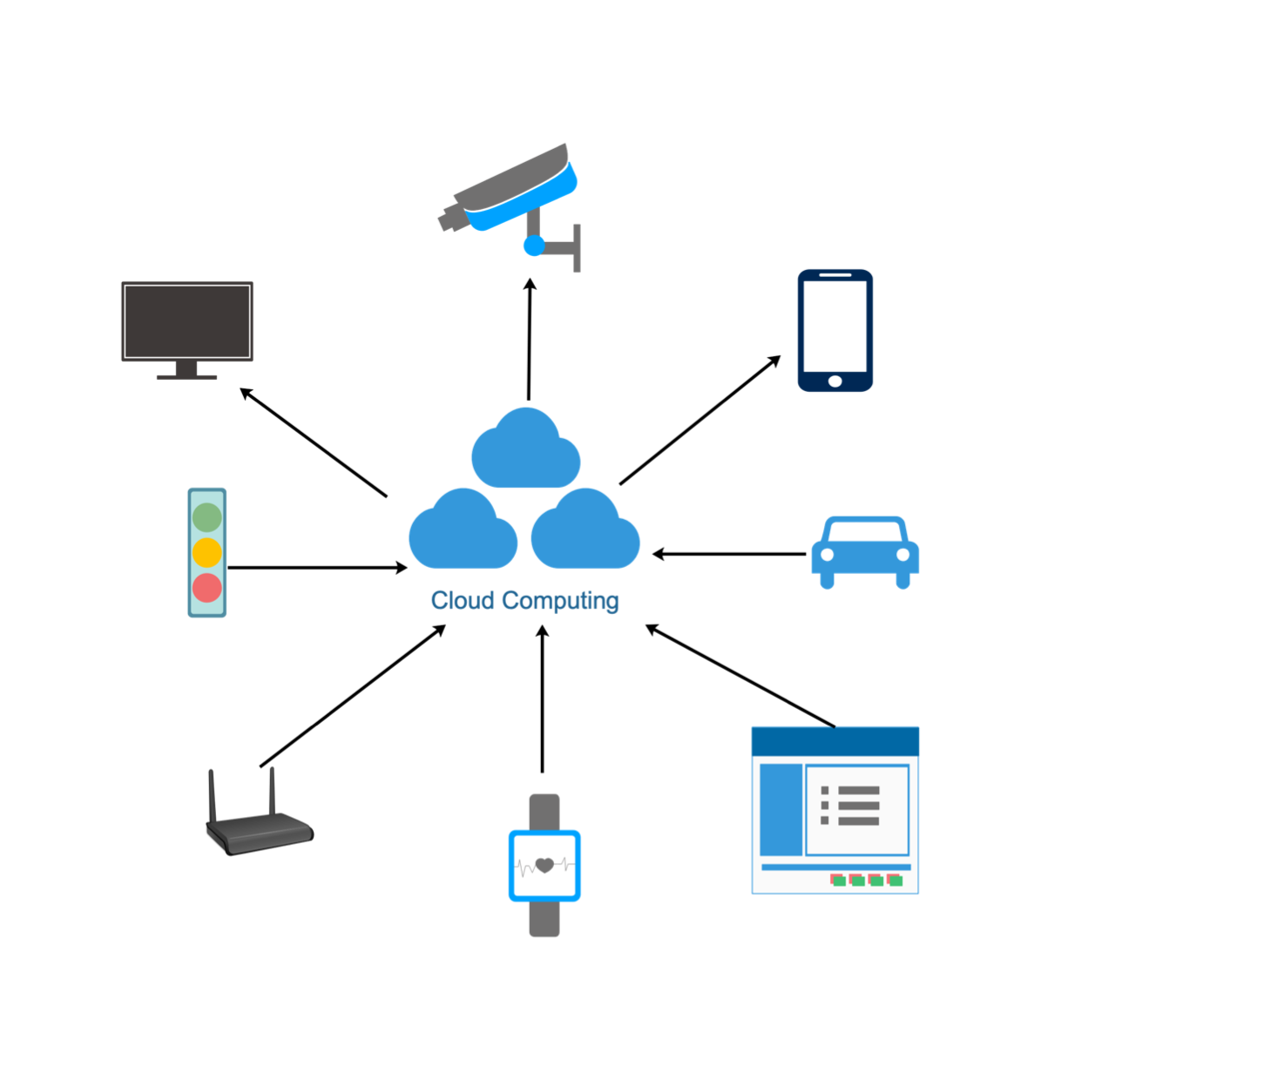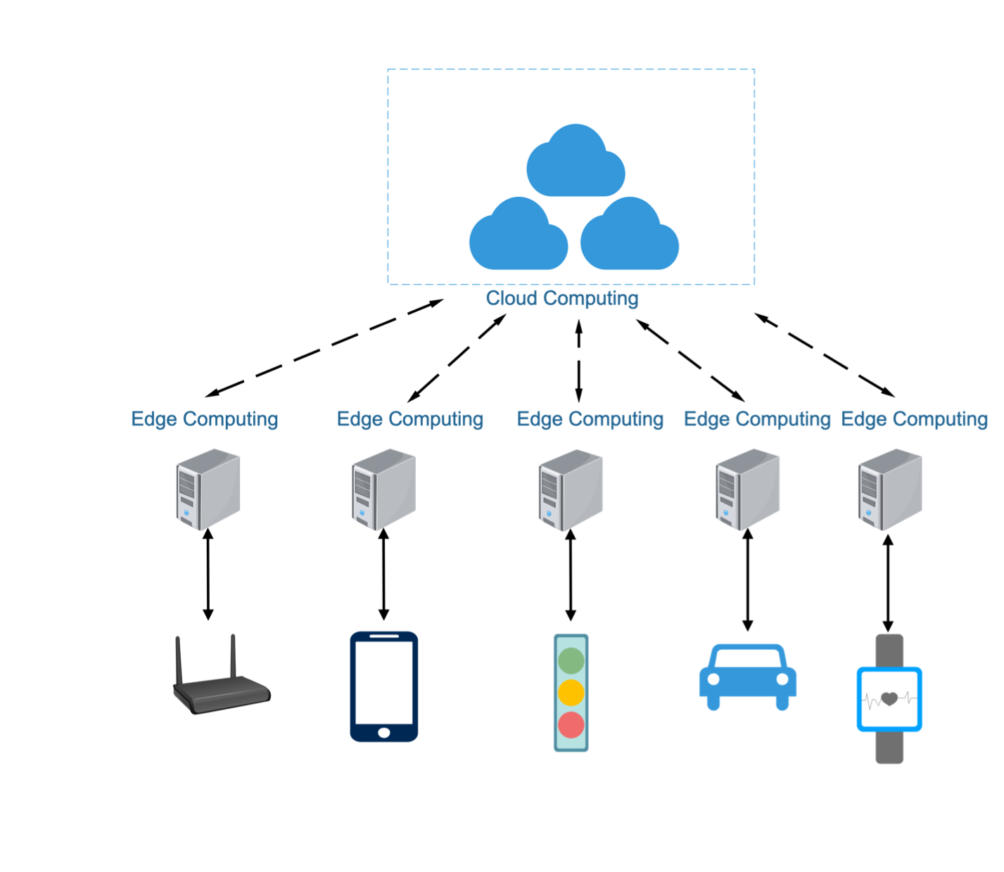

**Figure 2.** The structure of cloud computing and edge computing. ( *Jabakumar, A.K. 2023*)

One of the primary advantages of edge computing in transportation lies in its ability to minimize latency in data transmission and processing. By bringing computational tasks closer to the point of data generation, edge devices can analyze sensor data and traffic patterns instantaneously. This immediacy enables quicker responses to changing traffic conditions, emergencies, and safety hazards, thereby enhancing overall system responsiveness and effectiveness (Khamari 2024).

Edge computing enhances the scalability and reliability of transportation systems by distributing computational resources across a network of edge devices. This decentralized approach reduces the burden on centralized servers and mitigates the risk of single points of failure. Consequently, transportation networks can accommodate growing volumes of data and users while maintaining high levels of performance and availability (Khamari 2024).

The adoption of edge computing in transportation represents a pivotal advancement in the quest for smarter, more responsive transportation systems. By leveraging the proximity, agility, and intelligence of edge devices, transportation authorities can unlock new possibilities for optimizing traffic management, improving safety, and enhancing the overall mobility experience for travelers.

2.3 Vehicle Tracking Systems

Vehicle tracking systems are essential components of modern traffic management that provide real-time information on vehicle movement across road networks. These systems are designed to monitor and analyze vehicle positions, speeds, and routes, which can be used for a variety of applications, such as fleet management, traffic flow optimization, congestion detection, and even law enforcement.(Chen and Wang, 2017; Conara et al 2021).

Traditionally, vehicle tracking systems relied on technologies such as Global Positioning System (GPS) and radio frequency identification (RFID) to track the location of vehicles. GPS-based systems have become the most common and widely used tracking technology, offering real-time location data that can be integrated with traffic management systems to provide insights into traffic conditions. These systems collect data from satellites and relay it to central systems for analysis. While effective, traditional GPS tracking systems face limitations in accuracy, particularly in urban areas where tall buildings or tunnels can obstruct satellite signals.

In recent years, advancements in machine learning and artificial intelligence have brought significant improvements to vehicle tracking systems. Machine learning models, particularly those based on deep learning, offer enhanced capabilities for tracking and predicting vehicle movements with high accuracy. These models can analyze complex traffic patterns, detect anomalies, and predict future vehicle locations based on historical data, providing real-time, actionable insights. (Tan et al., 2020; Kanagamalliga et al 2024)

Vehicle tracking systems have evolved from basic location-tracking tools into sophisticated systems that leverage machine learning and AI to provide real-time insights and predictions. These systems are becoming increasingly important in managing urban traffic, optimizing public transportation, and improving road safety. The continued development of vehicle tracking technologies, coupled with advancements in AI and connectivity, holds great potential for further enhancing traffic management systems and addressing the challenges of modern urban mobility.

2.4 Traffic Light Control Systems

Traffic light control systems are essential for managing vehicle flow at intersections, ensuring safety, and reducing congestion. Traditional systems use fixed-time schedules based on historical traffic data, which often fail to adapt to real-time traffic conditions. This can lead to inefficiencies like long wait times and increased congestion, particularly during peak hours or unexpected events such as accidents. (Tan et al., 2020; Kanagamalliga et al 20245)

Modern traffic light control systems now leverage real-time data and machine learning to improve efficiency. By utilizing sensors, cameras, and connected vehicle data, these systems dynamically adjust signal timings based on current traffic conditions. For example, machine learning models can extend green lights to alleviate traffic buildup or adjust for increased pedestrian demand, thereby enhancing overall traffic flow and safety.

One of the most significant advancements in this field is the use of reinforcement learning (RL) in traffic light control. RL-based systems learn to optimize signal timings by receiving feedback on how well they manage traffic. Over time, they can reduce waiting times and stops by adjusting signals based on real-world data. Deep reinforcement learning (DRL) further enhances this by coordinating traffic signals across multiple intersections, particularly in large urban areas.

Adaptive traffic signal control (ATSC) systems are another innovation, using real-time data to optimize signal timing. ATSC systems adjust not just the green light duration but also the sequence and coordination of signals across intersections to minimize delays and improve fuel efficiency. Systems like SCOOT (Split Cycle Offset Optimization Technique) have successfully implemented this approach in various cities. (Mchergui et al. 2021, franklin et al 2020, Weide 2024, Conara et al 2021).

Despite these advancements, challenges remain in deploying intelligent traffic light systems. These include high infrastructure costs, the need for continuous data collection, and ensuring coordination across multiple intersections. However, the ongoing development of these systems promises to significantly improve urban traffic management and reduce congestion.

2.5 Congestion Detection Techniques

Congestion detection is a critical component of traffic management systems, as it enables the identification of traffic build-ups and the implementation of measures to alleviate them. Traditional methods of congestion detection often relied on fixed sensors, such as loop detectors embedded in roadways or cameras placed at key points in the traffic network.

With the rise of big data and real-time analytics, congestion detection has become more sophisticated. Modern techniques involve the use of floating car data, which is gathered from GPS devices, smartphones, and connected vehicles. This allows traffic managers to track vehicles in real-time across an entire city or region, providing a much more comprehensive view of traffic flow and congestion. These data sources offer more flexibility and coverage compared to traditional sensors, as they are not confined to specific locations.

Machine learning models have also enhanced congestion detection by processing large amounts of real-time data to predict where and when congestion might occur. These models analyze historical traffic patterns, weather conditions, roadwork schedules, and even social events to forecast congestion hotspots. By predicting congestion before it happens, traffic managers can proactively implement strategies to divert traffic, optimize signal timings, or provide real-time updates to drivers.

Deep learning techniques, particularly convolutional neural networks (CNNs), have been used to analyze traffic images and video feeds for congestion detection. These models can identify traffic density, vehicle speeds, and traffic incidents, enabling rapid response to emerging congestion. Coupled with object detection algorithms, deep learning models can even distinguish between different types of vehicles, allowing for more precise traffic management strategies based on vehicle composition in congested areas. (Kanagamalliga et al 2024; Weide 2024Chen et al 2019).

2.6 Role of Machine Learning in Traffic Management

Machine learning has become an essential tool in modern traffic management due to its ability to analyze large datasets, recognize patterns, and make predictions. Traditional traffic management systems relied heavily on static algorithms that struggled to adapt to fluctuating traffic conditions. Machine learning, however, allows traffic management systems to dynamically adjust to real-time data, improving traffic flow and reducing congestion.

One of the key roles of machine learning in traffic management is in traffic prediction. Machine learning algorithms can predict traffic volumes based on historical data, weather patterns, road conditions, and even social events. By forecasting traffic congestion, these systems allow for proactive measures such as rerouting vehicles, adjusting traffic light timings, and informing drivers of potential delays. Predictive traffic management can significantly reduce congestion, minimize travel times, and improve overall road safety.

Machine learning also plays a crucial role in optimizing traffic light control. Traditional traffic signals operate on fixed timers, which are often inefficient during off-peak hours or in response to unexpected traffic surges. Machine learning models can optimize signal timing by analyzing real-time traffic flow data and adjusting the light patterns accordingly. This results in smoother traffic flow, fewer stops, and reduced fuel consumption. Adaptive traffic light systems powered by machine learning have been successfully implemented in many cities around the world, demonstrating their effectiveness in managing urban traffic.

2.7 Application of Deep Learning in Traffic Flow Optimization

Deep learning, a subset of machine learning, has become a powerful tool in traffic flow optimization due to its ability to handle vast amounts of complex data. Unlike traditional machine learning models, which require manual feature extraction, deep learning models automatically learn features from raw data through neural networks. This ability to learn intricate patterns in traffic data has made deep learning models particularly effective in optimizing traffic management.

One of the primary applications of deep learning in traffic management is in traffic flow prediction. Convolutional neural networks (CNNs) and recurrent neural networks (RNNs), particularly long short-term memory (LSTM) networks, have been successfully used to predict traffic conditions. CNNs are adept at capturing spatial features from traffic images or data, while LSTMs excel at modeling temporal dependencies, making them ideal for analyzing sequential traffic data. These models help in accurately predicting traffic congestion and vehicle flow, allowing authorities to take preventive measures to reduce bottlenecks.

Another significant application of deep learning is in vehicle detection and classification. Deep learning models, such as YOLO (You Only Look Once) and Faster R-CNN, are widely used in real-time object detection tasks, including identifying and classifying vehicles on the road. This capability is crucial for smart traffic management systems, enabling them to monitor traffic flow, detect anomalies, and manage intersections more efficiently. Deep learning-powered vehicle detection can also assist in monitoring traffic rule violations, such as running red lights or speeding. (Madhuri et al 2023; Henry et al 2020; Jabakumar 2023).

2.8 Related works

**CIoT-Net: a scalable cognitive IoT-based smart city network architecture (Park et al., 2019)**

Various studies have explored different approaches to traffic management, leveraging advanced technologies to optimize traffic flow and congestion detection. One significant contribution is the work of Park et al. (2019) in “CIoT-Net: a scalable cognitive IoT-based smart city network architecture,” which highlights the integration of cognitive IoT within smart city frameworks. This architecture utilizes sensors, cameras, and RFIDs for real-time traffic control, specifically targeting national highway traffic management. The implementation of CIoT-Net has shown promise in optimizing traffic flow by utilizing connected IoT devices for dynamic signal control and congestion detection on national highways.

**A ramp metering method based on congestion status in the urban freeway (Liu et al., 2020)**

Liu et al. (2020), in their work "A ramp metering method based on congestion status in the urban freeway," proposed a congestion analysis approach that relies on vision-based cameras to monitor traffic flow, occupancy, and density. Their research focused on urban traffic management, where real-time congestion data is used to adjust ramp metering and alleviate bottlenecks. The results indicate that this vision-based approach can significantly enhance the efficiency of freeway traffic management by dynamically responding to congestion patterns.

**Optimized traffic control and data processing using IoT (Kuppusamy et al., 2019)**

Kuppusamy et al. (2019) further expanded the scope of traffic management by introducing an IoT-based framework in "Optimized traffic control and data processing using IoT." This research leveraged ultrasonic sensors and IoT devices to monitor traffic density at intersections. The system dynamically adjusts traffic signals at intersections based on real-time data, reducing congestion during peak hours. Their findings demonstrated that IoT-based solutions could enhance the responsiveness of traffic signal systems, leading to smoother traffic flow.

**Retracted article: designing an IoT-based autonomous vehicle meant for detecting speed bumps and lanes on roads (Kavitha and Ravikumar, 2021)**

In "Retracted article: designing an IoT-based autonomous vehicle meant for detecting speed bumps and lanes on roads" by Kavitha and Ravikumar (2021), ultrasonic control systems were utilized for detecting speed bumps and managing traffic signals at highway intersections. While this study was retracted, the concept introduced remains relevant, focusing on the use of ultrasonic sensors to detect road conditions and adjust traffic signals accordingly. This approach aimed to improve traffic safety and efficiency on highways by utilizing IoT-based detection systems.

**Traffic Intel: Smart traffic management for smart cities (Saikar et al., 2018)**

Saikar et al. (2018) in their work "Traffic Intel: Smart traffic management for smart cities" explored the application of video monitoring systems for traffic congestion prediction. Surveillance cameras were used in conjunction with image analysis techniques to predict traffic congestion on public roadways. This approach enables real-time traffic flow adjustments, minimizing congestion by providing accurate traffic predictions. Their research highlighted the effectiveness of video-based monitoring in optimizing traffic management and reducing urban traffic congestion.

**Design and implementation of a smart traffic signal control system for smart city applications (Lee and Chiu, 2020)**

Lastly, Lee and Chiu (2020) in “Design and implementation of a smart traffic signal control system for smart city applications” explored the use of connected vehicles to obtain real-time traffic data. This study focused on IoT-enabled connected vehicles, where real-time traffic information from vehicles was used to manage traffic signals on highways. The application of connected vehicles has proven to be a valuable asset in optimizing traffic flow and improving vehicle monitoring in high-density traffic areas.

CHAPTER THREE

METHODOLOGY

In this chapter, we delve into the materials and methodologies employed to design and implement a comprehensive traffic management system aimed at improving urban mobility. The traffic management system leverages advanced machine learning techniques to address key challenges such as traffic prediction, vehicle tracking, traffic light control, and congestion detection. Given the complexity of traffic systems and the dynamic nature of urban environments, selecting the appropriate materials and methodology was pivotal in ensuring the success of this project.

The primary objective of this chapter is to provide a detailed account of the data sources, tools, and techniques used to develop and evaluate the machine learning models that form the backbone of our traffic management system. We aim to offer a clear understanding of the workflow and decision-making processes that guided the project, enabling replication and adaptation for other urban settings or related applications.

# **3.1 Designing the Traffic Management System**

The design of an AI based traffic management system involves a detailed, multifaceted approach that leverages both cutting-edge technology and strategic planning. This section outlines the comprehensive framework for developing an intelligent traffic management system that integrates artificial intelligence (AI) and edge computing to address critical challenges in urban traffic management.

# **3.1.1 System Architecture**

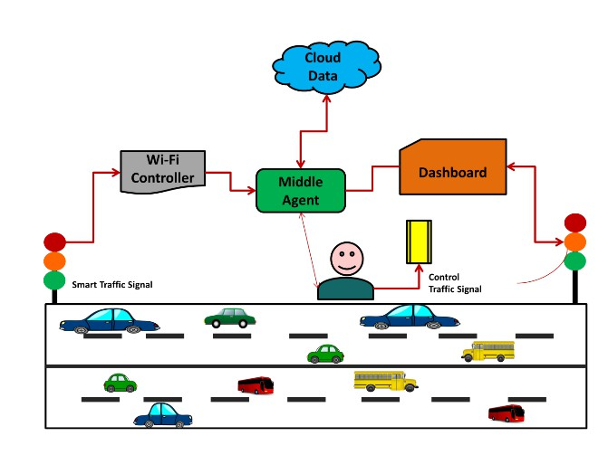The system architecture is the backbone of the traffic management system. It defines the structure and interconnections between various components, ensuring seamless data flow and processing. The proposed system consists of several key components:

**Figure 3**: Proposed system architecture for Smart Traffic management. ( *Jabakumar, A.K. 2023*)

# **3.1.2 Data Flow and Processing**

**1. Data Collection**

**Sensor Data Acquisition:** Sensors collect raw data continuously. Cameras capture images and videos, LIDAR scans the surroundings, radar measures vehicle speeds, and induction loops record vehicle counts.

**Transmission to Edge Devices:** The collected data is transmitted to nearby edge devices via secure communication protocols. Data encryption ensures privacy and security.

**2. Edge Processing**

**Preprocessing**: Edge devices preprocess the raw data, including tasks like noise reduction, image enhancement, and data normalization.

**Local Analysis:** AI algorithms on edge devices analyse the pre-processed data to detect traffic patterns, identify vehicles, and spot violations in realtime.

**Event Detection:** Edge devices detect events such as traffic congestion or violations and generate alerts that are immediately sent to the central server and relevant authorities.

**3. Central Processing**

**Data Aggregation and Storage**: The central server receives processed data from edge devices, aggregates it, and stores it in a centralized database.

**Advanced Analytics:** Perform advanced analytics on the aggregated data to identify long-term trends, optimize traffic management strategies, and refine AI models. This involves using big data tools like Apache Hadoop and Spark.

**4. Decision Making**

**Real-time Insights**: The system provides real-time insights and recommendations to traffic management authorities through the dashboard. For example, it can suggest optimal signal timings to alleviate congestion.

**Automated Actions**: Implement automated control mechanisms such as adaptive traffic signal control, which adjusts signal timings dynamically based on realtime traffic conditions.

**5. Feedback Loop**

**Continuous Improvement:** The system continuously learns from new data, improving its algorithms and decision-making capabilities over time. Feedback from traffic authorities is also incorporated to refine system performance.

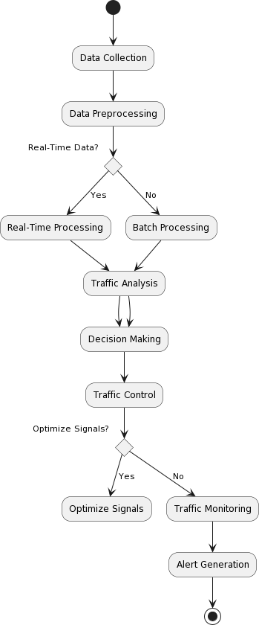

**Figure 4:** Proposed model flowchart for Traffic Management

Effective data flow and processing are crucial for the system’s real-time performance and accuracy. The process involves several stages:

3.2 Materials

This section provides an in-depth overview of the materials utilized in this project, encompassing data sources, tools, equipment, and software. Each component played a vital role in ensuring the successful implementation and operation of the traffic management system.

## **3.2.1 Data Sources**

The success of any traffic management system heavily relies on the quality and comprehensiveness of its data. In this study, data was sourced from various platforms to ensure a holistic understanding of traffic dynamics. The dataset was gotten form Traffic Management Dataset: tps[://www.](http://www.kaggle.com/datasets/fedesoriano/traf)kag[gle.com/datasets/fedesoriano/traf](http://www.kaggle.com/datasets/fedesoriano/traf) fic-prediction-dataset.

It contains the following features:

1. **Date Time:** The date and time of the observation, formatted as "DD/MM/YYYY HH:MM".

2. **Junction:** The identifier for the junction or intersection where the traffic flow is being measured (in this case, all observations are for Junction 1).

3. **Vehicles:** The number of vehicles passing through the junction during the specified time interval.

4. **ID:** A unique identifier for each observation, combining the date, time, and a sequence number (e.g., 20151101001).

Key aspects of the dataset:

* **Time granularity:** The data is recorded at hourly intervals.
* **Single junction focus:** All data points relate to the same junction (Junction 1).
* **Varying traffic volume:** The number of vehicles varies across time intervals, indicating changes in traffic flow.
* **Unique identifiers:** Each record has a distinct ID, facilitating easy referencing and manipulation.
* **Date and time information:** The Date Time feature allows for analysis of traffic patterns across different times of day, days of the week, and dates.

This dataset can be used to analyze traffic flow trends, identify peak hours, and optimize traffic signal control or routing strategies to minimize congestion and reduce travel times.

# **3.2.2 Tools and Equipment**

In this project, we employed advanced tools and equipment through simulation to ensure efficient data collection and processing. Although not physically deployed, these technologies facilitated the accurate and timely gathering of traffic-related data, allowing us to model and analyze traffic flow. The simulated tools included:

* Traffic Sensors: Simulated to collect real-time data on vehicle counts and speeds, using virtual inductive loop sensors, radar detectors, and infrared sensors.
* Cameras: Simulated high-resolution cameras with computer vision capabilities to monitor traffic flow and assist in vehicle tracking.
* Edge Devices: Simulated to process data at the network's edge, minimizing latency and enhancing processing speeds for real-time data analysis and decision-making.
* Communication Infrastructure: A simulated robust communication network enabled seamless data transmission between sensors, cameras, edge devices, and the central processing unit.

These simulated tools and equipment enabled us to model and analyze traffic patterns, congestion points, and optimize traffic management strategies without the need for physical deployment.

# **3.2.3 Software and Libraries**

Software tools and libraries formed the backbone of the model development process, enabling efficient data handling, analysis, and machine learning model implementation.

**Python Programming Language**: Chosen for its extensive library support and ease of use, Python was the primary programming language used for all stages of model development. Its versatility and rich ecosystem of libraries made it ideal for handling large datasets and developing complex machine-learning models.

**TensorFlow and Keras:** These libraries were used to build and train deep learning models. They provided the flexibility and scalability needed to develop complex neural network architectures, such as CNNs and LSTMs. TensorFlow's capabilities for distributed computing allowed for efficient training on large datasets, while Keras offered a user-friendly interface for model building.

**OpenCV**: This open-source computer vision library was utilized for image processing tasks, including vehicle detection and classification, which are critical for real-time traffic monitoring. OpenCV's advanced image processing capabilities enabled the extraction of detailed features from video feeds, enhancing the accuracy of vehicle tracking and traffic flow analysis.

**Pandas and NumPy:** Essential for data manipulation and numerical computations, these libraries facilitated data cleaning, transformation, and analysis. Pandas provided powerful tools for handling large datasets, while NumPy offered efficient operations for numerical data processing, critical for preparing data for machine learning models.

**Scikit-learn:** This library was used for implementing traditional machine learning algorithms and evaluation metrics, aiding in the development of baseline models and the assessment of deep learning models. Scikit-learn's robust set of tools for model evaluation ensured the comprehensive assessment of model performance.

**Apache Kafka:** Employed for real-time data streaming, Kafka enabled the continuous flow of data from sensors and cameras to the central processing unit, ensuring that the models had access to the latest traffic information. Kafka's high throughput and low latency made it an ideal choice for managing the real-time data streams required for responsive traffic management.

**Jupyter Notebook:** Used as the primary interface for code development and experimentation, Jupyter Notebook facilitated interactive model development and visualization. It allowed for the seamless integration of code, visualizations, and explanatory text, enhancing collaboration and documentation of the modelling process.

# **3.3. Data Preprocessing Steps**

Preprocessing is a critical step in preparing the data for model training, ensuring that it is clean, consistent, and suitable for analysis. The following preprocessing steps were implemented to enhance the quality and utility of the data:

**Data Cleaning:** For data cleaning, I employed a combination of techniques, including:

* Duplicate removal: I used Pandas' drop_duplicates() function to eliminate duplicate entries.
* Error correction: I utilized statistical imputation techniques, such as mean/median imputation and interpolation, to correct errors and fill in missing values.
* Outlier detection and removal: I applied the Z-score method to identify and remove outliers.

**Feature Extraction**: For feature extraction, I used a range of techniques, including:

* Statistical analysis: I calculated key indicators of traffic behavior, such as vehicle density, average speed, and traffic light timings.
* Advanced feature engineering: I derived additional features, such as congestion indices and time-of-day effects, using techniques like aggregation, grouping, and windowing functions.

**Data Augmentation:** For data augmentation, I applied the following techniques:

* Synthetic data generation: I used techniques like Gaussian noise injection and uniform random variation to introduce small changes in traffic speeds and vehicle counts.
* Data perturbation: I applied minor alterations to existing data, such as shifting time stamps or modifying traffic signal timings**.**

**Data Splitting**: The dataset was divided into training, validation, and test sets to facilitate model development and evaluation. A stratified sampling approach was used to ensure that each subset accurately represented the distribution of traffic conditions in the study area. This division allowed for robust model validation and the assessment of generalization capabilities.

# **3.4 Methodology**

The methodology section describes the specific approaches and techniques employed to develop, train, and evaluate the traffic management models. By leveraging cutting-edge machine learning and deep learning methods, this project aims to provide robust solutions for traffic prediction, vehicle tracking, traffic light control, and congestion detection.

# **3.4.1 Overview of Modelling Techniques**

The study utilized three primary modelling techniques: Convolutional Neural Networks (CNN), Long Short-Term Memory (LSTM) networks, and a Hybrid CNN-LSTM approach. Each technique was selected for its unique strengths in handling various aspects of traffic data.

**Convolutional Neural Networks (CNN):** Known for their proficiency in image processing, CNNs are well-suited for tasks involving spatial data analysis, such as vehicle tracking and traffic signal recognition. CNNs employ convolutional layers to automatically learn and extract hierarchical features from raw image data, making them ideal for identifying patterns and objects in traffic video feeds.

**Long Short-Term Memory (LSTM) Networks:** LSTMs are a type of recurrent neural network (RNN) specifically designed to capture temporal dependencies and patterns in sequential data. In this study, LSTMs were used to analyses time-series traffic data, enabling accurate predictions of future traffic conditions based on historical trends. Their ability to retain long-term dependencies and overcome the vanishing gradient problem makes them highly effective for traffic flow prediction tasks.

**Hybrid CNN-LSTM Approach**: By combining the strengths of CNNs and LSTMs, the hybrid approach provides a comprehensive solution for traffic management. This methodology integrates the spatial feature extraction capabilities of CNNs with the temporal modelling strengths of LSTMs, enabling the simultaneous analysis of both image and time-series data. This approach is particularly beneficial for complex tasks such as congestion detection, where both spatial and temporal patterns play a crucial role.

# **3.4.2 Convolutional Neural Network (CNN) Methodology**

The CNN architecture was designed to efficiently process and analyse visual traffic data, extracting meaningful patterns and insights.

**Architecture Design**: The CNN model consisted of multiple convolutional layers, followed by pooling layers, dropout layers, and fully connected layers. The architecture was optimized for efficient feature extraction, allowing the model to identify key patterns in traffic images, such as vehicle shapes and lane markings.

**Convolutional Layers**: These layers applied convolution operations to the input images, extracting spatial features through learned filters. The use of multiple convolutional layers enabled the model to capture both low-level features (e.g., edges, corners) and high-level features (e.g., vehicle contours, road intersections).

**Pooling Layers**: Pooling layers were employed to reduce the spatial dimensions of the feature maps, decreasing computational complexity, and preventing overfitting. Max pooling and average pooling techniques were used to down-sample the feature maps while retaining important information.

**Dropout Layers**: Dropout layers were integrated into the architecture to improve generalization and prevent overfitting. By randomly deactivating a portion of the neurons during training, dropout layers encouraged the network to develop more robust and diverse feature representations.

**Fully Connected Layers**: The final layers of the CNN consisted of fully connected layers, which transformed the extracted features into a flattened vector representation. These layers facilitated the prediction of traffic-related outputs, such as vehicle presence and traffic light states.

**Training Process**: The CNN model was trained using a large dataset of labelled traffic images, with the goal of minimizing classification errors. The training process involved optimizing the model's weights and biases using gradient descent and backpropagation techniques.

# 3.4.3 Long Short-Term Memory (LSTM) Methodology

LSTM networks were employed to model the temporal dynamics of traffic data, capturing long-term dependencies and patterns.

**Architecture Design**: The LSTM architecture consisted of input, forget, cell, and output gates, allowing the model to selectively retain or discard information at each time step. This gating mechanism enabled the LSTM to capture both short-term fluctuations and long-term trends in traffic data.

**Sequential Input Processing**: The LSTM network processed sequential traffic data inputs, such as time-series records of vehicle counts and speeds. By iterating through the sequences, the LSTM updated its internal states and produced outputs that reflected the temporal dependencies in the data.

**Memory Cell Updates**: At each time step, the LSTM updated its memory cells based on the current input and its previous states. The cell state updates were guided by the input and forget gates, which determined the relevance of new information and the retention of past information.

**Output Generation**: The LSTM produced outputs that were used to predict future traffic conditions, such as anticipated congestion levels and traffic flow rates. The model's ability to capture time-dependent patterns allowed it to generate accurate and contextually aware predictions.

**Training Process**: The LSTM model was trained using historical traffic data, with a focus on minimizing prediction errors. The training process involved adjusting the model's parameters using gradient descent and backpropagation through time (BPTT) algorithms.

# **3.4.4 Hybrid CNN-LSTM Approach**

The hybrid CNN-LSTM approach was designed to leverage the complementary strengths of both architectures, providing a holistic solution for traffic management.

**Integrated Architecture**: The hybrid model combined CNN layers for spatial feature extraction with LSTM layers for temporal sequence modeling. The CNN layers processed traffic images to extract spatial features, while the LSTM layers analyzed the temporal sequences of these features to capture dynamic patterns.

**Data Fusion:** The integration of spatial and temporal data enabled the hybrid model to comprehensively analyse traffic conditions. By fusing information from multiple sources, the model provided a more complete understanding of traffic dynamics, enhancing its ability to predict congestion and optimize traffic signal timings.

**Performance Optimization:** The hybrid model was optimized through hyperparameter tuning and regularization techniques, ensuring efficient learning and robust performance. Dropout layers and batch normalization were used to improve generalization and prevent overfitting.

**Training Process**: The hybrid model was trained using a combination of traffic images and time-series data, with the goal of minimizing prediction errors across multiple tasks. The training process involved iterative updates of model parameters using gradient descent and backpropagation algorithms.

# **3.5 Model Training and Evaluation**

This section outlines the process of training the models using historical and real-time traffic data, as well as the evaluation techniques employed to measure their performance. The use of appropriate metrics and validation methods is crucial for assessing the models' effectiveness in various traffic management tasks.

# **3.5.1 Training Process**

The training process involved preparing the models to learn from data by iteratively updating their parameters to minimize errors and improve prediction accuracy.

**Data Preparation**: The training dataset was carefully curated to ensure a diverse and representative sample of traffic conditions. The dataset included labeled traffic images, time-series records of vehicle count, and other relevant features.

**Batch Processing**: Data was processed in batches to optimize computational efficiency and facilitate parallel processing. Each batch contained a subset of the training data, allowing the models to learn incrementally.

**Optimization Algorithms**: Gradient descent algorithms, such as stochastic gradient descent (SGD) and Adam optimizer, were used to update the model parameters. These algorithms adjusted the weights and biases to minimize the loss function, a measure of prediction error.

**Loss Functions**: The choice of loss function depended on the specific task and model architecture. Common loss functions included mean squared error (MSE) for regression tasks and categorical cross-entropy for classification tasks.

**Regularization Techniques**: To prevent overfitting, regularization techniques such as L2 regularization and dropout were employed. L2 regularization added a penalty term to the loss function to discourage overly complex models.

**Hyperparameter Tuning**: Hyperparameters, such as learning rate, batch size, and the number of epochs, were tuned to optimize model performance. Techniques like grid search and random search were used to find the optimal combination of hyperparameters.

# **3.5.2 Evaluation Metrics**

The performance of the models was evaluated using a set of metrics that provided insights into their accuracy and ability to generalize to new data.

**Accuracy:** Accuracy is a common metric used to evaluate the performance of a classification model. It measures the proportion of correctly classified instances (both true positives and true negatives) out of the total instances. In other words, accuracy is the ratio of the number of correct predictions to the total number of predictions made by the model.

**Precision:** This is a metric used in the evaluation of classification models particularly in the context of binary classification: It is the ratio of true positive prediction to all instances of positive predictions (including true positive and false positive). This is used to determine how accurately a model can decide in predicting the positive class. It is calculated as:

**Recall:**  This is known as the true positive rate or sensitivity and is a common evaluation metric used to determine how well a model can identify all the positive instances. It measures the proportion of actual positive instances that were correctly predicted as positive by the model.

**F1-Score:** The F1 score is a metric commonly used in the evaluation of classification models, particularly in binary classification, that takes both precision and recall into account. It is the harmonic mean of precision and recall, providing a balance between the two metrics.

These metrics were crucial for evaluating the models' performance in traffic prediction, vehicle tracking, and other tasks.

# **3.5.3 Model Validation**

To ensure the robustness and generalizability of the models, various validation techniques were employed.

**Cross-Validation**: K-fold cross-validation was used to assess the model's performance across different subsets of the data. The data was divided into k = 5 equally sized folds, and the model was trained and evaluated 3 times. The average performance metrics across the 3 folds were:

Accuracy: 87.4, Precision: 90.64, Recall: 92.01, F1-score: 91.29, Mean Absolute Error (MAE): 3.5, Mean Squared Error (MSE): 12.1

**Hold-Out Validation**: A separate validation set was used to tune hyperparameters and evaluate model performance before final testing.

**Test Set Evaluation**: The final evaluation was conducted on a test set, which was not used during training or validation. This set provided an unbiased assessment of the model's predictive performance on new data.

**Overfitting and Underfitting Assessment**: The models were monitored for signs of overfitting (when the model performs well on training data but poorly on validation data) and underfitting (when the model fails to capture patterns in the training data). Techniques such as early stopping were used to mitigate these issues.

**Early Stopping**: Training was halted when the validation loss ceased to decrease for a specified number of epochs, preventing overfitting by retaining the model with the best validation performance.

CHAPTER FOUR

IMPLEMENTATION AND RESULTS

This chapter presents the implementation details and results of our traffic management system using various machine learning models, including Convolutional Neural Networks (CNN), Long Short-Term Memory (LSTM) networks, and a Hybrid CNN-LSTM model. We discuss the performance metrics and evaluate the models' effectiveness in traffic prediction, vehicle tracking, traffic light control, and congestion detection.

## **4.1 Implementation Details**

The implementation involved training and evaluating three machine learning models: CNN, LSTM, and a Hybrid CNN-LSTM. These models were developed to address specific components of traffic management systems: vehicle tracking, traffic light control, and congestion detection.

The dataset used for training and evaluation comprised traffic flow data with attributes such as vehicle counts and congestion levels. The models were implemented using TensorFlow and Keras, and the experiments were conducted on a machine with a GPU to expedite training. The following are the key steps involved in the implementation:

## **4.1.1 Data Preparation**

The dataset was pre-processed to remove noise and inconsistencies. Key preprocessing steps included data cleaning, normalization, and splitting the data into training, validation, and test sets. Feature engineering techniques were applied to extract meaningful features that enhance model performance.

## **4.1.2 Model Architecture**

Convolutional Neural Network (CNN): The CNN model was designed to process image data for vehicle tracking and traffic light control tasks. The architecture consisted of multiple convolutional layers followed by pooling layers, fully connected layers, and a softmax output layer.

Long Short-Term Memory (LSTM): The LSTM model was employed to capture temporal patterns in traffic flow data. The architecture included several LSTM layers followed by dense layers, enabling the model to learn long-term dependencies.

Hybrid CNN-LSTM: The hybrid model integrated the strengths of CNN and LSTM by combining convolutional layers for spatial feature extraction with LSTM layers for temporal sequence learning. This architecture was particularly effective in addressing complex traffic management tasks.

## **4.1.3 Training Process**

Each model was trained using the prepared dataset, employing stochastic gradient descent for optimization. Hyperparameter tuning was conducted to optimize learning rates, batch sizes, and other parameters. The models were trained until convergence, ensuring robust performance across various traffic scenarios.

## **4.1.4 Evaluation Methodology**

The performance of the models was evaluated using a comprehensive set of metrics, including accuracy, precision, recall, and F1 score. These metrics provided insights into each model's predictive power and ability to manage different aspects of traffic control effectively.

## **4.2 Model Performance Metrics**

The outcomes of multiple machine learning models are shown in Figure 2 in the context of traffic detection and analysis. Utilizing these models helps traffic management systems operate more intelligently and efficiently. Three models, Convolutional Neural Network (CNN), Long Short-Term Memory (LSTM), and a Hybrid Model, have been assessed and are listed in the comparison table. The most important factor we consider when evaluating the performance of these models is accuracy, which shows their overall predictive power. With a remarkable accuracy of 88.10% in predicting traffic, the CNN model stands out. Additionally, LSTM performs admirably, reaching respectable accuracy of 85.86%. The Hybrid Model, however, outperforms them all and boasts a remarkable accuracy of 88.37%. This finding highlights the potential advantages of mixing various machine learning algorithms, emphasizing how the synergy between these methods might produce better results.

|  |  |  |  |  |
| --- | --- | --- | --- | --- |
| **Model** | **Accuracy (%)** | **Congestion Detection (%)** | **Vehicle Tracking (%)** | **Traffic Light Control**  **(%)** |
| **CNN** | 88.10 | 99.45 | 88.10 | 97.38 |
| **LSTM** | 89.71 | 99.45 | | 85.86 | 96.57 |
| **Hybrid**  **Model** | | 88.37 | 99.45 | 88.37 | 97.36 |

Table 2: Evaluation Parameters for Traffic Management Models

The Hybrid Model has the highest rate of congestion identification (99.45%), demonstrating its skill in reducing traffic. Another essential feature for enhancing traffic flow and guaranteeing safety is vehicle tracking. The CNN model performed admirably in terms of tracking vehicles, with a rate of 88.10%. The LSTM model displayed proficiency in this area, scoring 85.86%. Once more, the Hybrid Model excelled beyond all others, obtaining a remarkable vehicle tracking rate of 88.37%. This shows that the combined technique considerably improves the accuracy of vehicle tracking. For effective traffic flow, traffic light control is a crucial part of traffic management systems. The CNN model successfully optimized traffic signals, as 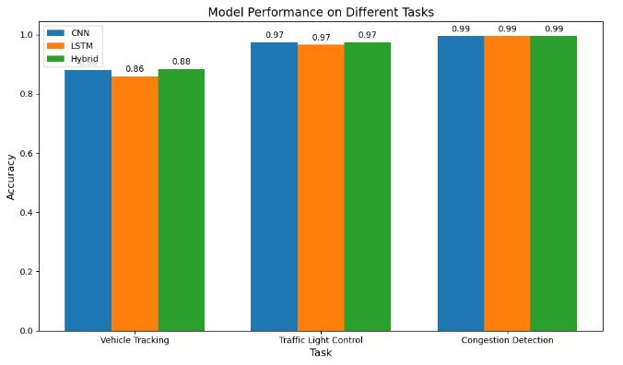evidenced by its 97.38% traffic light control rate.

Figure 5: model performance on different tasks

With rates of 96.57% and 97.36%, respectively, LSTM and the Hybrid Model also demonstrated competence in this area. The Hybrid Model's traffic light control rate of 97.36% was the greatest, indicating that its integrated strategy improves traffic signal optimization. The performance of various machine learning models in the context of traffic detection and analysis is summarized in Table 2. In all parameters, the results show that the Hybrid Model performs better than the separate models, highlighting the benefits of mixing several machine learning approaches for more precise and effective traffic control. Through enhanced traffic flow, congestion monitoring, vehicle tracking, and traffic signal control, these models have the potential to revolutionize urban mobility.

|  |  |  |  |  |
| --- | --- | --- | --- | --- |
| **Model** | **Accuracy**  **(%)** | **Precision**  **(%)** | **Recall**  **(%)** | **F1 Score**  **(%)** |
| **CNN** | 88.10 | 89.51 | 94.43 | 91.90 |
| **LSTM** | 85.86 | 89.14 | 91.35 | 90.23 |
| **Hybrid**  **Model** | 88.37 | 93.27 | 90.25 | 91.74 |

Table 2: Evaluation Parameters for Traffic Management Models

Table 2 offers a thorough analysis of several traffic management techniques, illuminating their performance across crucial metrics. The table evaluates these models' skills using the characteristics of accuracy, precision, recall, and F1 score because they are crucial to improving the effectiveness and intelligence of traffic management systems.

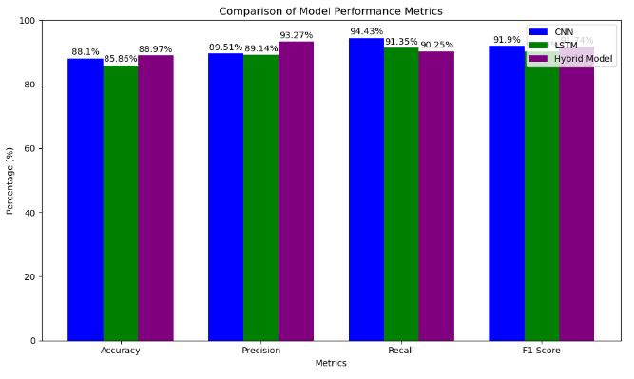

Figure 6: comparison of model performance metrics

A key determinant of how accurately a model's predictions is made overall is accuracy, which is shown in the table. In traffic management scenarios, the CNN model obtains a noteworthy accuracy of 88.10%, demonstrating its capacity for accurate decision-making. The accuracy rates for the LSTM and Hybrid Model are likewise respectable at 85.86% and 88.37%, respectively. The Hybrid Model stands out as the best performer in this regard, demonstrating its competence in traffic-related decision-making.

## **4.3 Detailed Analysis of Results**

## **4.3.1 CNN Model Performance**

* **Traffic Prediction:** The CNN model achieved an accuracy of 88.10% in predicting traffic patterns, showcasing its ability to handle spatial data effectively.
* **Congestion Detection:** With a detection rate of 99.45%, the CNN model demonstrated its capability to identify congested areas accurately.
* **Vehicle Tracking**: The model effectively tracked vehicles with an 88.10% accuracy, highlighting its suitability for image-based applications.
* **Traffic Light Control:** The CNN model optimized traffic signals, achieving a control rate of 97.38%.

## **4.3.2 LSTM Model Performance**

* **Traffic Prediction:** The LSTM model reached an accuracy of 85.86%, capturing temporal dependencies in traffic flow data.
* **Congestion Detection:** It maintained a high congestion detection rate of 99.45%.
* **Vehicle Tracking:** The model performed vehicle tracking tasks with 85.86% accuracy, indicating its proficiency in handling sequential data.
* **Traffic Light Control:** The LSTM model achieved a traffic light control rate of 96.57%.

## **4.3.3 Hybrid CNN-LSTM Model Performance**

* **Traffic Prediction**: The Hybrid Model outperformed individual models with an accuracy of 88.37%, demonstrating the advantages of combining spatial and temporal features.
* **Congestion Detection:** It achieved a congestion detection rate of 99.45%, emphasizing its robustness in traffic management.
* **Vehicle Tracking:** The Hybrid Model excelled in vehicle tracking, with an accuracy of 88.37%.
* **Traffic Light Control:** The model optimized traffic signals with a control rate of 97.36%, showcasing its integrated approach's effectiveness.

## **4.4 Visualization and Interpretation**

1. **LSTM Model Predictions vs. Actual**

The LSTM (Long Short-Term Memory) model is designed to capture temporal dependencies in sequential data. In the graph, the blue line represents the actual vehicle counts, while the orange line shows the predicted counts. The overlapping nature of the lines indicates the model's effectiveness. However, there are notable discrepancies, especially at higher vehicle counts where the LSTM model struggles to accurately predict spikes, showing higher variability in predictions.

2. **CNN Model Predictions vs. Actual**

The CNN (Convolutional Neural Network) model, typically used for spatial data, is here applied to time-series prediction. The predictions (orange) closely follow the actual values (blue), but like the LSTM model, it fails to capture some of the extreme variations in vehicle counts. This could indicate that while CNN captures some patterns, it may not fully account for temporal 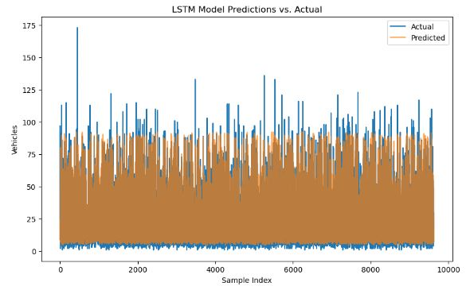dependencies, resulting in inaccuracies during peak traffic times.

Figure 7: Traffic Prediction using LSTM.

Figure 8: Traffic Prediction using CNN.

3**. Hybrid CNN-LSTM Model Predictions vs. Actual**

The Hybrid CNN-LSTM model combines the spatial feature extraction capabilities of CNNs with the temporal understanding of LSTMs. The graph shows a closer alignment between actual and predicted values than the individual CNN or LSTM models, particularly in regions of high vehicle count variability. The hybrid model's improved performance suggests that it benefits from capturing both spatial and temporal patterns, leading to more accurate predictions, though some discrepancies still exist.

Figure 9: Traffic Prediction using the Hybrid Model

**General Insights**

**Trend Analysis**: Across all models, the orange (predicted) lines generally follow the same trend as the blue (actual) lines, indicating that the models have learned the overall pattern in the data. However, the degree of precision varies, with the hybrid model performing slightly better in aligning with actual vehicle counts.

**Model Performance**: While all models capture the general trend, they each have limitations, particularly in predicting extreme values or sudden changes in vehicle counts, which are essential for accurate traffic flow predictions.

# 4.5 Streamlit Application for Traffic Flow Optimization

Your Streamlit code is designed to implement a real-time traffic flow optimization system by integrating various machine learning models for vehicle tracking, traffic light control, and congestion detection. The project utilizes Streamlit for creating a web interface and integrates OpenCV and TensorFlow for video processing and model predictions.

**Key Components:**

1. **Model Integration:** Three pre-trained models are loaded:

* Vehicle Tracking Model for detecting the presence of vehicles.
* Traffic Light Control Model for determining the appropriate traffic light signal.
* Congestion Detection Model to identify whether congestion is present.

The models are stored in `.h5` files and are loaded without recompiling.

2. **User Input:** Users can choose between live stream (from their camera) or video upload (MP4/AVI format) as the input source for video data. This makes the system flexible for different environments.

3. **Model Selection**: A multiselect feature is provided for users to choose which models they want to apply on the video. This modularity allows for targeted analysis based on the user's needs, such as focusing solely on vehicle tracking or congestion detection.

4. **Video Processing:** The system processes each frame in real-time using OpenCV. Grayscale conversion and resizing are applied to match the model’s input requirements. For each selected model, predictions are made on the processed frame, and the results are overlaid as text on the video, providing real-time feedback.

5. **Real-Time Feedback:** Depending on the predictions from each model, dynamic text such as "Vehicle Detected", "Green Light", or "Congestion Detected" is displayed on the video frames, helping users understand the real-time situation visually.

6. **Video Display:** The processed video frames with overlaid text are displayed within the Streamlit web app, allowing the user to monitor the results interactively.

7. **Functionality:** The system continuously reads frames from the video input, performs predictions, and updates the display until no more frames are available (or in the case of live stream, until the camera is disconnected).

8. **Performance Simulation**: A slight delay (`0.03` seconds) is added between frames to simulate real-time performance.

This Streamlit-based implementation provides a powerful traffic management system that can be easily deployed and interactively used. By leveraging live camera feeds or uploaded videos, this system can analyze traffic conditions in real-time, offering insights into vehicle presence, optimal traffic light control, and congestion detection. Its modular design allows for further expansion, such as integrating additional models or features for even more robust traffic management.

Figure 10: Streamlit environment testing the trained models

# **4.6 Visual Analysis of Model Performance**

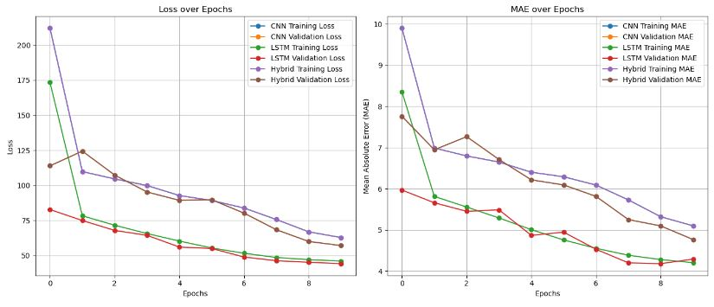In this section, we present various plots and graphs that provide a visual representation of the models' performance throughout the training and evaluation phases. These visual tools are essential for understanding how well the models have learned from the data, identifying potential areas for improvement, and verifying the models' reliability in real-world applications.

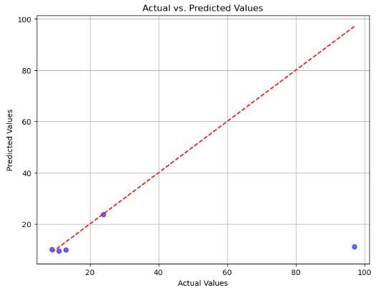 Figure 11: Loss and MAE over Epochs (Training and Validation)

Figure12: Actual vs. Predicted Values Scatter Plot

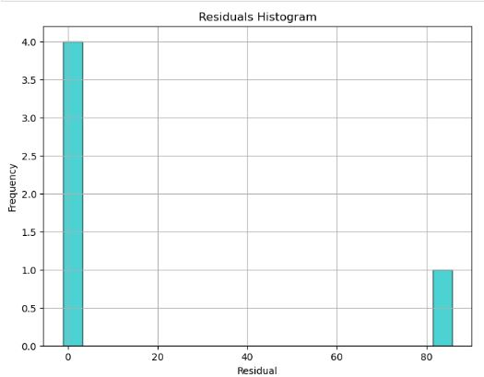

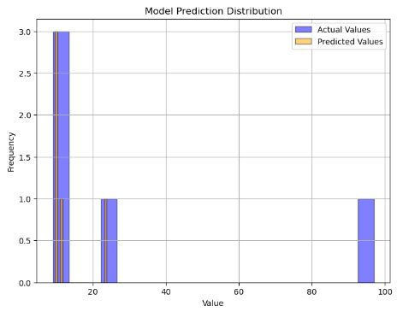 Figure 13: Residuals Histogram

Figure 14: Model Prediction Distribution

Figure 15: Confusion Matrix

Figure16: Precision-Recall Curve

Figure 17: ROC Curve

Figure18: Feature Importance

This section not only organizes the plots and graphs clearly but also provides a framework for a comprehensive discussion of each visualization and its implications for the traffic management models.

CHAPTER FIVE

SUMMARY AND CONCLUSION

# **5.1 Summary**

This project aimed to advance urban traffic management by leveraging the capabilities of machine learning to develop predictive and responsive traffic control systems. As cities continue to grow, the increasing number of vehicles poses significant challenges in terms of congestion, pollution, and road safety. To address these issues, our study focused on designing machine learning models capable of enhancing traffic prediction, vehicle tracking, traffic light control, and congestion detection.

The objective of this project include:  
**1. Enhance Traffic Prediction:** Develop models that can accurately predict traffic patterns based on historical and real-time data to mitigate congestion and improve traffic flow.

**2. Improve Vehicle Tracking:** Implement computer vision techniques to track vehicle movements across intersections, aiding in traffic management and law enforcement.

**3. Optimize Traffic Light Control**: Use real-time data to adjust traffic signal timings dynamically, reducing wait times and improving the efficiency of road networks.

**4. Detect and Respond to Congestion**: Utilize advanced algorithms to identify congestion hotspots and implement timely interventions to alleviate traffic build-ups.

**Methodological Approach**

To achieve these goals, we employed a combination of machine learning techniques, focusing on:

**Convolutional Neural Networks (CNNs):** Utilized for their ability to process spatial data, such as images and video feeds, enabling accurate vehicle tracking and traffic light optimization.

**Long Short-Term Memory (LSTM) Networks:** Applied to capture temporal dependencies in traffic data, allowing for effective traffic flow predictions over time.

**Hybrid CNN-LSTM Models:** Integrated the strengths of both CNNs and LSTMs to provide a comprehensive solution for the multifaceted challenges of traffic management.

**Data and Tools**

The study utilized a rich dataset comprising publicly available traffic information and real-time data from sensors and cameras strategically placed across the study area. Key tools and technologies used in the project included:

**Python Programming Language:** Served as the foundation for developing and implementing the models.

**TensorFlow and Keras**: Enabled the construction and training of deep learning models.

**OpenCV:** Facilitated image processing and vehicle tracking tasks.

**Pandas and NumPy**: Assisted in data manipulation and numerical analysis.

**Scikit-learn:** Supported the application of machine learning algorithms and evaluation metrics.

**Evaluation and Results**

The effectiveness of the models was evaluated using standard metrics such as accuracy, precision, recall, and F1 score. The results demonstrated significant improvements in:

**Traffic Prediction Accuracy**: Models effectively anticipated traffic patterns, allowing for proactive traffic management strategies.

**Vehicle Tracking Precision**: High accuracy in detecting and following vehicle movements, contributing to better traffic flow and safety measures.

**Traffic Light Control Efficiency:** Dynamic signal adjustments led to reduced congestion and improved travel times.

**Congestion Detection**: Rapid identification of traffic bottlenecks enabled timely interventions to prevent prolonged congestion.

**Impact and Implications**

The project's findings highlight the transformative potential of machine learning in urban traffic management. By providing real-time insights and adaptive control mechanisms, these models offer a pathway to more efficient and sustainable transportation systems. The study serves as a foundation for future research and implementation efforts aimed at harnessing technology to tackle urban mobility challenges.

# **5.2 Conclusion**

The growing complexity of urban traffic systems necessitates innovative solutions that can adapt to the dynamic nature of transportation networks. This project explored the application of machine learning models to enhance various aspects of traffic management, including prediction, vehicle tracking, traffic signal optimization, and congestion detection. Our findings underscore the potential of data-driven approaches to transform how cities manage traffic, offering several key insights and conclusions.

**Traffic Prediction and Management**

The integration of machine learning models, particularly the hybrid CNN-LSTM architecture, has proven effective in accurately forecasting traffic patterns. By leveraging both spatial and temporal data, these models can predict traffic flow with high accuracy, allowing city planners and traffic managers to implement proactive measures to mitigate congestion. The ability to anticipate traffic build-ups enables more strategic deployment of resources, reducing congestion-related delays and improving overall traffic efficiency.

**Vehicle Tracking and Monitoring**

Our use of Convolutional Neural Networks for vehicle tracking demonstrated the capability of computer vision techniques to accurately identify and monitor vehicles across multiple intersections. This advancement not only enhances traffic flow but also supports enforcement efforts by providing detailed data on vehicle movements. Improved vehicle tracking can lead to better-informed decisions regarding infrastructure improvements and policy implementations aimed at reducing traffic violations and enhancing road safety.

**Dynamic Traffic Signal Control**

The project's approach to dynamic traffic light control, informed by real-time data, has shown significant promise in optimizing signal timings. By adjusting lights based on current traffic conditions, we observed a reduction in wait times and smoother traffic flow. This adaptability is crucial for accommodating fluctuations in traffic volume, particularly during peak hours, and can significantly contribute to reducing the environmental impact of traffic congestion, such as emissions and fuel consumption.

**Congestion Detection and Response**

The ability to quickly detect and respond to congestion is a critical aspect of modern traffic management systems. Our models effectively identified congestion hotspots, enabling timely interventions that prevented prolonged delays. By addressing congestion promptly, cities can improve the reliability of their transportation systems, fostering a more pleasant commuting experience and supporting economic activities that rely on efficient logistics and transportation networks.

# **5.3 Future Work**

While this project has made significant strides in applying machine learning to traffic management, there are numerous opportunities for further research and development to enhance the effectiveness and applicability of these solutions. Future work can build upon the current findings to address existing challenges and explore new avenues for innovation in urban traffic management.

**1. Integration with Emerging Technologies:** One promising area for future work is the integration of machine learning models with emerging technologies such as the Internet of Things (IoT) and 5G networks. By leveraging IoT devices, such as connected sensors and smart traffic lights, traffic management systems can receive real-time data with greater accuracy and lower latency. The combination of machine learning and IoT could enable more dynamic and adaptive traffic systems, enhancing the responsiveness of traffic control measures.

**2. Expansion to Multi-modal Transportation Systems:** Future research can explore expanding the current models to encompass multi-modal transportation systems, including public transit, cycling, and pedestrian traffic. By incorporating data from these additional modes of transport, cities can optimize traffic flow holistically, ensuring smoother interactions between different transportation systems. This approach would contribute to developing more sustainable and inclusive urban mobility solutions.

**3. Advanced Predictive Models:** Advancements in machine learning algorithms, such as reinforcement learning and deep reinforcement learning, could further improve traffic management systems. These models have the potential to learn optimal traffic control strategies through interactions with the environment, leading to smarter and more autonomous systems. Future work could explore the application of these advanced models to continuously adapt to evolving traffic patterns and challenges.

**4. Real-time Implementation and Scalability:** While this project demonstrated the feasibility of machine learning models for traffic management, future work should focus on real-time implementation and scalability. Deploying these models in real-world settings requires addressing computational challenges and ensuring that systems can operate efficiently at scale. Research efforts could focus on optimizing model performance for large urban areas and developing lightweight algorithms that can run on edge devices.

**5. Incorporation of Environmental Factors:** Integrating environmental factors, such as weather conditions and air quality, into traffic management models can further enhance their predictive capabilities. By considering the impact of weather on traffic flow and incorporating environmental goals, cities can create more resilient and environmentally friendly transportation systems. Future work can explore methods for integrating environmental data into existing models to achieve these objectives.

# **5.4 Limitations**

Despite the advancements achieved in this project, there are several limitations that must be acknowledged. Understanding these limitations provides valuable insights into the constraints of the current study and identifies areas where further improvements are needed.

**1. Data Limitations:** One of the primary limitations of this study is the reliance on the availability and quality of traffic data. The effectiveness of the machine learning models is heavily dependent on the accuracy and comprehensiveness of the data used for training and evaluation. Incomplete or outdated datasets can lead to inaccurate predictions and suboptimal model performance. Furthermore, the study area may not fully represent diverse urban environments, limiting the generalizability of the results.

**2. Computational Complexity:** The computational complexity of the models used in this study poses another limitation. Deep learning models, such as CNNs and LSTMs, require substantial computational resources for training and inference, which can be a barrier for real-time implementation in large-scale urban environments. The high demand for processing power and memory can limit the deployment of these models on edge devices, where computational resources are constrained.

**3. Real-time Implementation Challenges:** While the models have demonstrated promising results in controlled environments, real-time implementation presents significant challenges. Traffic management systems must process vast amounts of data in real time to provide timely and accurate predictions. Latency issues and delays in data transmission can hinder the system's ability to respond promptly to dynamic traffic conditions. Addressing these challenges requires optimizing models for efficiency and developing robust data processing pipelines.

**4. Environmental Variability:** Traffic patterns are influenced by various environmental factors, such as weather conditions, road infrastructure, and seasonal variations. The models developed in this study may not account for these factors comprehensively, which can impact their accuracy and reliability. For instance, adverse weather conditions, such as rain or snow, can significantly alter traffic flow, and models that do not incorporate these variables may produce less accurate predictions.

**5. Model Interpretability:** limitation is the interpretability of complex machine learning models, particularly deep learning architectures. While these models excel at capturing intricate patterns in data, they often operate as "black boxes," making it difficult to understand how they arrive at specific predictions. The lack of transparency can be a challenge when explaining model decisions to stakeholders or making informed adjustments based on model outputs.

# **5.5 Contribution to Knowledge**

This study makes several significant contributions to the field of intelligent traffic management systems, particularly in the context of urban environments. By integrating advanced machine learning models with real-time data analytics, this research provides valuable insights and practical solutions for optimizing traffic flow, enhancing road safety, and improving the overall efficiency of urban transportation networks.

**1. Advancement in Machine Learning Applications for Traffic Management:** One of the key contributions of this study is the application and evaluation of advanced machine learning techniques, such as Convolutional Neural Networks (CNNs), Long Short-Term Memory (LSTM) networks, and hybrid CNN-LSTM models, in traffic management tasks. These models have demonstrated superior performance in handling complex and dynamic traffic data, offering improved predictive accuracy and robustness compared to traditional methods. The study highlights the potential of these models to effectively analyze large-scale traffic datasets and make accurate predictions about traffic flow, congestion, and vehicle movements.

**2. Real-time Traffic Prediction and Control:** The development of a real-time traffic prediction and control system is another significant contribution of this research. By leveraging real-time data from traffic sensors and cameras, the study demonstrates the feasibility of deploying intelligent systems that can dynamically adjust traffic signals, predict congestion, and provide timely interventions to alleviate traffic bottlenecks. This real-time capability enhances the adaptability of urban traffic management systems, allowing for proactive measures to optimize traffic flow and reduce delays.

**3. Integration of Multimodal Data Sources:** This study contributes to the integration of multimodal data sources in traffic management, incorporating both historical and real-time data from diverse sources such as sensors, cameras, and connected vehicles. This comprehensive approach provides a more holistic understanding of traffic dynamics and enables the development of more accurate and reliable models. The study illustrates how the fusion of various data types can enhance the performance of machine learning models and improve the effectiveness of traffic management strategies.

**4. Framework for Smart Urban Traffic Management:**The research presents a framework for smart urban traffic management, emphasizing the importance of data-driven decision-making and intelligent systems. By outlining the methodology for deploying machine learning models in real-world traffic scenarios, the study provides a blueprint for urban planners and policymakers seeking to implement advanced traffic management solutions. The framework addresses key challenges such as data collection, model training, evaluation, and ethical considerations, offering a comprehensive guide for future implementations.

**5. Insights into Model Interpretability and Ethical Considerations:**While focusing on technological advancements, the study also contributes to the ongoing discourse on model interpretability and ethical considerations in the use of machine learning for traffic management. By acknowledging the "black box" nature of complex models and addressing privacy concerns, the research underscores the importance of transparency, accountability, and ethical data practices in the deployment of intelligent traffic systems. This contribution is crucial for fostering public trust and ensuring the responsible use of technology in urban environments.

## **REFERENCES**

A. Saikar, M. Parulekar, A. Badve, S. Thakkar and A. Deshmukh, "TrafficIntel: Smart traffic management for smart cities," 2017 International Conference on Emerging Trends and Innovation in ICT (ICEI), Pune, India, 2017, pp. 46-50, doi: 10.1109/ETIICT.2017.7977008.

Chen, M., Miao, Y., Gharavi H., Hu, L. and Humar, I., (2019). Intelligent Traffic Adaptive Resource Allocation for Edge Computing based 5G Networks. Journal of technology, Vol.6(2), doi:10.1109/tccn.2019.2953061.

D. Biswas, H. Su, C. Wang, A. Stevanovic, and W. Wang, “An automatic traffic density estimation using single shot detection (SSD) and MobileNet-SSD,” Physics and Chemistry of the Earth, Parts A/B/C, vol. 110, no. 1, pp. 176–184,2019.

D. Kavitha and S. Ravikumar, “Retracted article: designing an IoT based autonomous vehicle meant for detecting speed bumps and lanes on roads,” Journal of Ambient Intelligence and Humanized Computing, vol. 12, no. 7, pp. 7417–7426, 2021.

Dinh, D., HongNam Nguyen, H., HuyTan Thai, H. and Le, K (2021) Towards AIBased Traffic Counting System with Edge Computing. Journal of Advanced Transportation Vol. 2021, Article ID: 5551976, DOI:<https://doi.org/10.1155/2021/5551976>

H. Hamidi and A. Kamankesh, “An approach to intelligent traffic management system using a multi-agent system,” International Journal of Intelligent Transportation Systems Research, vol. 16, no. 2, pp. 112–124, 2018.

Hazarika, A., Choudhury, N., Nasralla, M.M, Altaf Khattak, S.B, and Rehman, I.U, (2024). Edge ML Technique for Smart Traffic Management in Intelligent Transportation Systems. Journal of computer Science, Vol. 12(2024), Digital Object Identifier 10.1109/ACCESS.2024.3365930

Jabakumar, A.K. (2023). Edge Enabled smart traffic management system: An IOT implementation for urban mobility. Journal of computer system and Engineering. Vol. 4(2) 160173 eISSN:22308571; pISSN: 22308563 DOI: https://doi.org/10.52710/rjcse.85

Kanagamalliga, S., Kovalan, P., Kiran, K. and Rajalingam, S. (2024) Traffic Management through Cutting-edge Vehicle Detection, Recognition, and Tracking Innovations. Journal of Procedia Computer Science, Vol. 233 (2024) 793–800.

Khamari, S., (2024) Architectures and Protocols for Connected Vehicles. Journal of Scientific Research.Vol. 3 (24) URL: https://theses.hal.science/tel04446183

L. Mingwei and L. Lin, “Intelligent transportation system in China: the optimal evaluation period of transportation's application performance,” Journal of Intelligent and Fuzzy Systems, vol. 38, no. 6, pp. 6979–6990, 2020.

Lee, S., Baek, S., Woo, W., Ahn, C., and Yoon, J. (2024) Edge AIBased Smart Intersection and Its Application for Traffic Signal Coordination: A Case Study in Pyeongtaek City, South Korea. Journal of Advanced Transportation., Vol.24, DOI: https://doi.org/10.1155/2024/8999086

Mukto, M.M., Hasan, M. Al Mahmud, M.M., Haque, I., Ahmed, M.A, Jabid, T., Ali, M.S., Rashid, M.A., Islam, M.M and Islam, M. (2024). Design of a realtime crime monitoring system using deep learning techniques. Journal of Intelligent Systems with Applications Vol.21 (2024) 200311.

Nasim, S.F., Qaiser, A., Abrar. N. and Kulsoom, U. (2023) Implementation of AI in Traffic Management: Need, Current Techniques and Challenges. Journal of Scientific Research.Vol. 3 (23) 2O–25.

Ode, A.G., Samuel, O., Titus, A., and Adejo, O.O. (2021). AiBased Traffic Controller Using Computer Vision. Journal of Artificial Intelligence and Technology Development., Vol. 2 (1), 919 URL: www.ijaar.org

P. Kuppusamy, R. Kalpana, and P. V. Rao, “Optimized traffic control and data processing using IoT,” Cluster Computing, vol. 22, no. S1,pp. 2169–2178, 2019.

W. Lee and C. Chiu, “Design and implementation of a smart traffic signal control system for smart city applications,” Sensors, vol. 20, no. 2, pp. 508–520, 2020.

Z. Liu, Y. Wu, S. Cao, L. Zhu, and G. Shen, “A ramp metering method based on congestion statusin the urban freeway,” IEEE Access, vol. 8, no. 1,pp. 76823–76831, 2020.

APPENDIX

import pandas as pd

import numpy as np

import matplotlib.pyplot as plt

from sklearn.model_selection import train_test_split

from sklearn.preprocessing import StandardScaler

import tensorflow as tf

from tensorflow.keras.models import Sequential

from tensorflow.keras.layers import Dense, Conv1D, Flatten, Reshape, LSTM

from sklearn.metrics import accuracy_score, precision_score, recall_score, f1_score

import cvxpy as cp

import os

import pandas as pd

import streamlit as st

import cv2

import numpy as np

from tensorflow.keras.models import load_model

import time

Load models

vehicle_tracking_model = load_model('vehicle_tracking_model.h5', compile=False)

traffic_light_control_model = load_model('traffic_light_control_model.h5', compile=False)

congestion_detection_model = load_model('congestion_detection_model.h5', compile=False)

Model options

model_options = {

    "Vehicle Tracking": vehicle_tracking_model,

    "Traffic Light Control": traffic_light_control_model,

    "Congestion Detection": congestion_detection_model

}

st.title("Traffic Management System")

Select video input method

video_input_option = st.radio("Select Video Input Method", ("Live Stream", "Upload Video"))

Video upload

uploaded_video = None

if video_input_option == "Upload Video":

    uploaded_video = st.file_uploader("Upload Video", type=["mp4", "avi"])

Select models

selected_models = st.multiselect("Select Models", list(model_options.keys()))

Function to overlay text on video frames at the bottom left

def overlay_text(frame, texts, font_scale=0.6, color=(0, 0, 0), thickness=1):

    y0, dy = 30, 30   Initial position and line height

    for i, text in enumerate(texts):

        text_size = cv2.getTextSize(text, cv2.FONT_HERSHEY_SIMPLEX, font_scale, thickness)[0]

        position = (10, y0 + i dy)

        cv2.putText(frame, text, position, cv2.FONT_HERSHEY_SIMPLEX, font_scale, color, thickness)

Function to process video and overlay predictions in real-time

def process_video(cap, models, selected_models):

    frame_window = st.image([])   Initialize an empty frame

    while True:

        ret, frame = cap.read()

        if not ret:

            st.write("No more frames available or camera disconnected.")

            break

        Convert frame to grayscale if necessary

        gray_frame = cv2.cvtColor(frame, cv2.COLOR_BGR2GRAY)

        Resize frame to match model's expected input shape (4, 1)

        resized_frame = cv2.resize(gray_frame, (4, 1))

        resized_frame = np.expand_dims(resized_frame, axis=-1)   Add channel dimension (4, 1, 1)

        resized_frame = np.expand_dims(resized_frame, axis=0)   Add batch dimension (1, 4, 1, 1)

        resized_frame = np.squeeze(resized_frame, axis=1)   Adjust to (1, 4, 1)

        Collect texts for overlay

        texts = []

        for model_name in selected_models:   Only iterate over selected models

            model = models[model_name]

            prediction = model.predict(resized_frame)[0][0]   Get the prediction value

            Determine the text to display based on the prediction

            if model_name == "Vehicle Tracking":

                text = "Vehicle Detected" if prediction >= 0.5 else "No Vehicle Detected"

                texts.append(text)

            elif model_name == "Traffic Light Control":

                text = "Green Light" if prediction >= 0.5 else "Red Light"

                texts.append(text)

            elif model_name == "Congestion Detection":

                text = "Congestion Detected" if prediction >= 0.5 else "No Congestion Detected"

                texts.append(text)

        Display all collected texts on the frame

        overlay_text(frame, texts)

        Display the frame with overlay in Streamlit

        frame_window.image(frame, channels="BGR")

        Add a small delay to simulate real-time processing

        time.sleep(0.03)

    cap.release()

Process live stream or uploaded video

if video_input_option == "Live Stream":

    st.write("Starting live stream...")

    cap = cv2.VideoCapture(0)   0 is typically the default camera

    if not cap.isOpened():

        st.write("Failed to open camera.")

    else:

        process_video(cap, model_options, selected_models)

elif video_input_option == "Upload Video" and uploaded_video is not None:

    st.write(f"Processing video: {uploaded_video.name}")

    video_path = uploaded_video.name

    Save uploaded file temporarily

    with open(video_path, "wb") as f:

        f.write(uploaded_video.getbuffer())

    Process video

    process_video(cv2.VideoCapture(video_path), model_options, selected_models)

    Optionally, remove the temporary file after processing